Smart acquafarming: revoluting fish farming with Iot and Ai

Capstone project proposal report

Supervised by:

Dr. Md. Ashraful Islam

Professor

Department of Computer Science and Engineering (CSE)

Deen, Faculty of science and engineering

University of Information Technology and Sciences

Submitted by:

|  |  |
| --- | --- |
| Name | Student Id |
| Md. Shakibul Islam Ramim | 2125051063 |
| Md. Nahian Islam Emon | 2125051114 |
| Fazlay Rabbi | 2125051070 |
| Sumi Akter | 2125051037 |

Department of Computer Science and Engineering

University of Information technology and Sciences

Autumn 2021

## INDEX

|  |  |  |
| --- | --- | --- |
| No | Topic Name | Page no |
| 1. | Introduction | 1 |
| 2. | Problem Statement | 1 |
| 3. | Objectives | 1 |
| 4. | Literature Review | 2 |
| 5. | Methodology | 2 |
| 6. | Result Framework | 3 |
| 7. | Expected Outcomes | 3 |
| 8. | Logical Diagram | 3 |
| 9. | Physical Diagram | 4 |
| 10. | Budget statement | 5 |
| 11. | Timeline | 5 |
| 12. | Conclusion | 5 |
| 13. | Reference | 6 |

### 1. Introduction

Smart aquafarming represents a significant leap in the evolution of fish farming. By integrating IoT and AI technologies, fish farms can now operate with greater efficiency and precision. This project aims to modernize traditional fish farming practices through the deployment of sensors and automated systems to monitor water quality, optimize feeding, and improve fish health.

### 2. Problem Statement

The traditional fish farming industry faces a number of challenges that hinder optimal production and sustainability. Some of these challenges include:

* Limited water quality control
* Inefficient feed utilization
* High disease prevalence
* Environmental impacts and inconsistent fish quality
* Lack of integrated monitoring, energy loss, and excessive costs
* High labor costs

### 3. Objectives

The main objectives of the Smart Aquafarming project are:

* Optimize water quality management using IoT sensors.
* Maximize feed efficiency through automation.
* Enhance disease detection using AI-driven algorithms.
* Enable continuous monitoring and predictive reporting.
* Increase productivity and reduce costs.

### 4. Literature Review

* The potential benefits of IoT sensors in smart aquafarming are well documented. Studies have shown that real-time water quality monitoring can reduce fish mortality by up to 30% [1].
* Optimized feeding schedules powered by IoT systems can reduce feed waste by 15-20%.
* Automated water and oxygen control mechanisms can reduce energy use by 25%, promoting more sustainable practices [2].
* Furthermore, predictive analytics allow farmers to optimize growth and harvesting, reducing operational costs by 10-15% [2].

### 5. Methodology

The methodology for this project is broken down into several key steps:

* Project Planning: Define objectives, conduct research, and estimate the budget.
* -Selection of IoT Components: Sensors for monitoring water parameters (O2, pH, temperature), smart valves for feeding, air pumps
* System Design and Architecture: Network infrastructure, cloud-based data storage, and control system development
* Installation of Sensors: Deploying sensors in fishponds/tanks and connecting them to controllers (e.g., Raspberry Pi)
* Software Development: Building the interface (mobile/web app), firmware for real-time data visualization, and alert systems.
* Testing and Calibration: Sensor calibration and system testing before full deployment.
* Deployment and Monitoring: Continuous system monitoring and performance evaluation

### 6. Results Framework

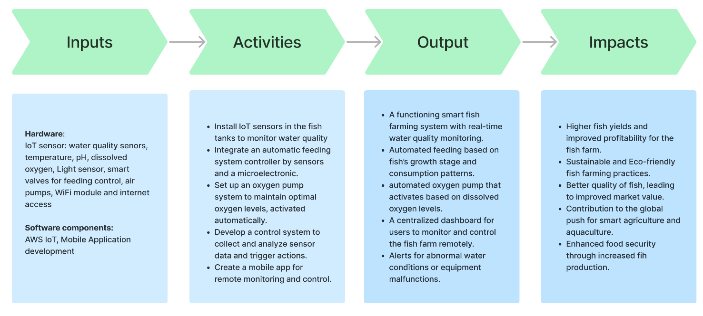

### 7. Logical Device

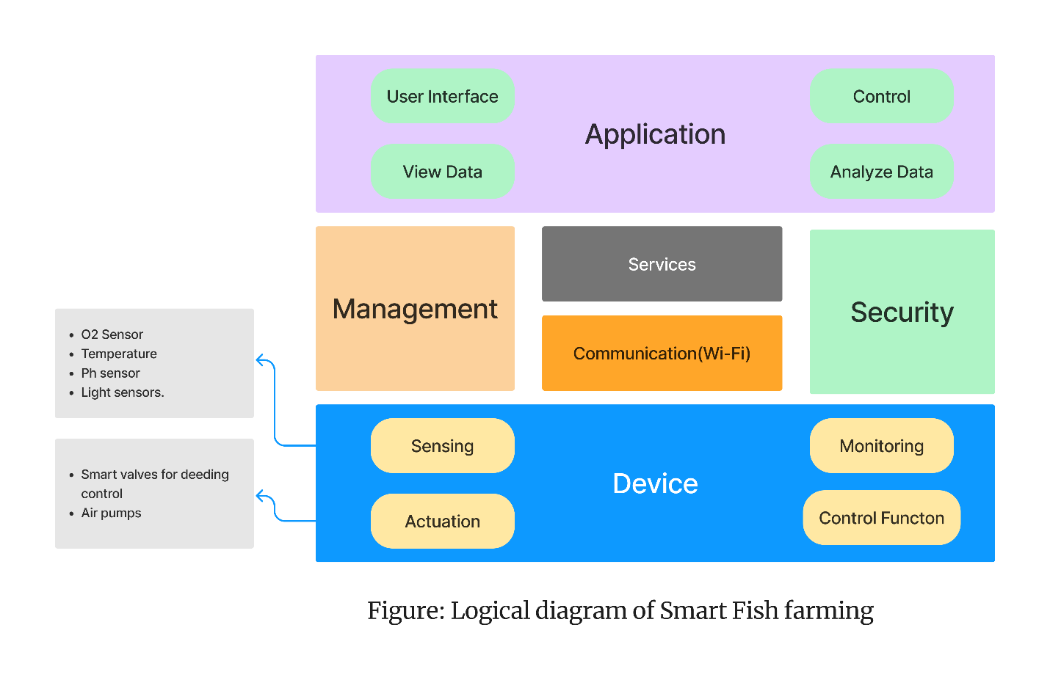

### 8. Physical Diagram

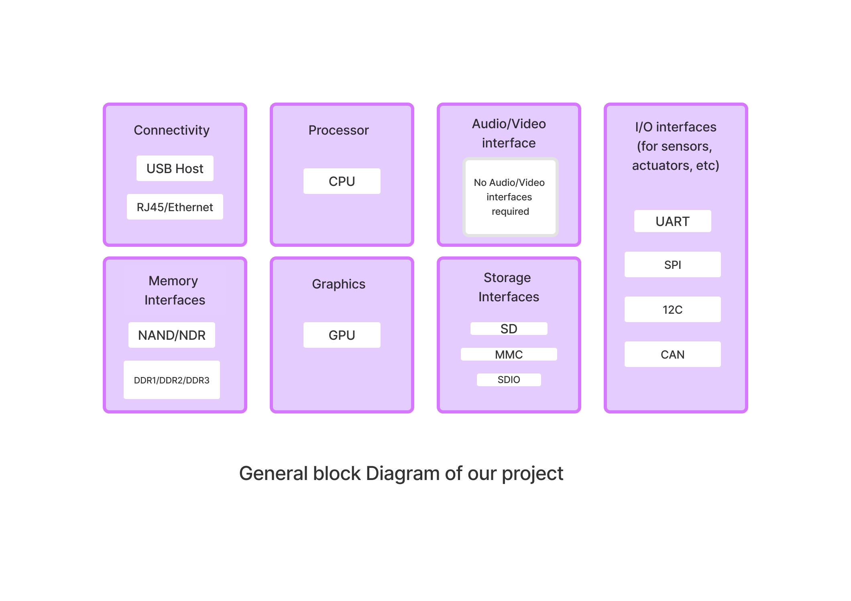

### 9. Expected Outcomes

Upon successful completion of the project, the following outcomes are expected:

* Development of a functional smart fishery prototype
* Early disease detection through AI models and predictive analysis
* Improved fish health and growth rates
* Reduced feed waste, lowering overall feeding costs.
* Performance evaluation report and a marketplace website for buying/selling fish.

### 10. Budget Estimation

### 11. Timeline

The project is expected to follow the below timeline:

* Project planning: 1 month
* System design: 1 month
* Development: 1 month
* Testing: 1 month
* Deployment and monitoring: 1 month
* Training and optimization: 2 months

### 12. Conclusion

The Smart Aquafarming project seeks to revolutionize fish farming by integrating IoT and AI technologies. This project will empower fish farmers with real-time monitoring capabilities, automation for feeding and oxygen control, and data-driven insights to optimize fish health and productivity. With sustain-

able practices at its core, this project has the potential to significantly enhance the profitability and environmental friendliness of fish farms.

## 13. References

* [1]Kiruthika, S. Usha, S. R. Kanaga, and R. Jaichandran. "IOT based automation of fish farming." *J. of Adv. Res. in Dynam. Control Syst* 9.1 (2017).
* [2]Chen, Chiung-Hsing, et al. "IoT-based fish farm water quality monitoring system." *Sensors* 22.17 (2022): 6700.
* [3]Nocheski, S., and Andreja Naumoski. "Water monitoring IoT system for fish farming ponds." *Industry 4.0* (2018).

The End